SIMATS ENGINEERING (SAVEETHA SCHOOL OF ENGINEERING)
Department of Computer Science and Engineering
CO5 ASSESSMENT TOOL 1
RESEARCH PAPER REVIEW / LITERATURE SURVEY
Course Code: CSA10 | Course Title: Software Engineering
CO5: Evaluate emerging technologies and societal impacts, maintaining and evolving software systems responsibly.

Student Details | Information
Student Name | Rishitha. Y
Register Number | 192424233
Assessment | Research Paper Review / Literature Survey
Weightage | 20%
Total Marks | 25

Declaration
I certify that this submission is my original academic work and that I have followed the guidelines specified for the assessment. The literature survey is organized around the required review, comparison, critical analysis, research gap, future directions, and references.
Purpose of the Report
This report provides a structured literature-survey format for reviewing research papers related to an assigned Software Engineering problem statement. It focuses on identifying relevant research, understanding existing approaches, comparing methods and tools, examining limitations, identifying unresolved issues, and proposing future directions. This structure directly follows the assessment requirements provided in the source document.
Report Structure
- Introduction and problem context
- Literature selection and review framework
- Individual research-paper review
- Comparative analysis using a structured table
- Critical analysis of limitations and challenges
- Research gap identification
- Future research directions and relevance
- Overall findings, conclusion, and references

1. INTRODUCTION AND PROBLEM CONTEXT
Software engineering continuously evolves as new technologies, development practices, tools, and intelligent systems are introduced. A literature survey helps a student understand how a problem has already been studied and what remains unresolved. The supplied assessment specifically requires students to review relevant research papers, summarize their objectives and methodologies, compare approaches, identify limitations, analyze research gaps, and propose future improvements.
A systematic literature review is useful because individual research papers often investigate the same broad problem from different perspectives. One paper may emphasize performance, another may focus on scalability, while another may investigate efficiency, reliability, usability, or responsible system evolution. Bringing these findings together creates a clearer picture of the research landscape.
The central objective of this literature survey is therefore not only to summarize papers, but also to critically examine them. The review should answer three important questions: what approaches currently exist, what limitations remain, and what improvements could address those limitations?
Key Objectives
- Identify relevant and credible research papers from journals, conferences, or scholarly databases.
- Summarize the objectives, methodologies, technologies, datasets, tools, and findings of selected papers.
- Compare existing approaches using suitable parameters such as accuracy, performance, scalability, efficiency, and methodology.
- Identify limitations and challenges affecting current approaches.
- Determine research gaps or unresolved issues.
- Suggest practical and relevant future research directions.
Importance of Literature Review
A well-prepared literature survey prevents duplication of existing work and helps position a proposed study within the existing research landscape. It also supports responsible software evolution because developers and researchers can understand known limitations before selecting technologies or designing new systems.
The assessment rubric emphasizes comprehensive paper review, meaningful comparison, critical analysis, practical future directions, and accurate documentation. These criteria are used as the organizing principles of this cleaned report.
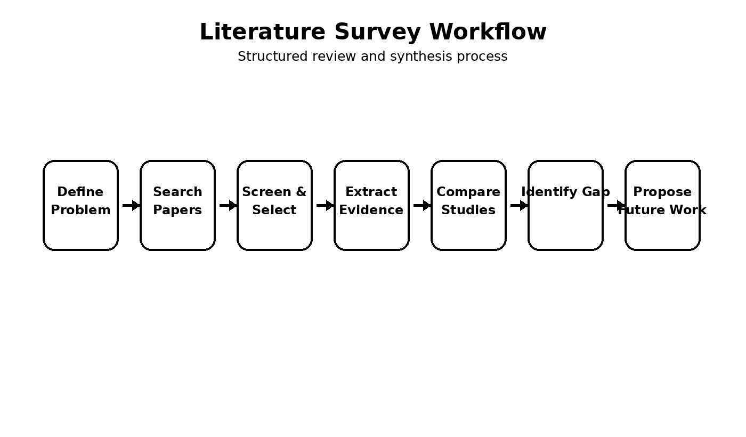
2. LITERATURE SURVEY METHODOLOGY
The literature survey follows a structured review process. First, the problem statement is clearly defined. Next, relevant research papers are selected using credibility and relevance as primary considerations. Each selected paper is then reviewed using a common set of parameters so that meaningful comparison is possible.
Stage | Activity | Expected Output
1 | Define problem statement | Clear research focus
2 | Search scholarly literature | Relevant candidate papers
3 | Screen papers | Final set of suitable papers
4 | Extract information | Objectives, methods, tools, datasets, findings
5 | Compare approaches | Comparative literature table
6 | Analyze limitations | Technical and practical challenges
7 | Identify research gap | Unresolved issue or opportunity
8 | Propose future work | Improvement directions
9 | Document references | Consistent citation and reference list
Literature Review Flowchart
START
Define assigned problem statement
Search relevant research papers
Screen for relevance and credibility
Select papers for detailed review
Extract objectives, methodology, tools, datasets and findings
Compare approaches and performance
Identify limitations and challenges
Determine research gap
Propose future research directions
Prepare citations and final report
END
Review Quality Checklist
- Papers should directly relate to the assigned problem.
- The review should cover methodology and major findings rather than only paper titles.
- Comparison should use common parameters.
- Limitations should be stated clearly.
- The research gap should follow logically from the reviewed literature.
- Future directions should address the identified gap.
- References should use one consistent academic style.
3. INDIVIDUAL RESEARCH PAPER REVIEW
Each selected research paper should be reviewed systematically. The source assessment asks students to summarize objectives, methodologies, technologies, datasets, and major findings. The following template provides a cleaned structure that can be repeated for each paper.
Parameter | Review Details
Paper Title | ____________________________________________
Author(s) and Year | ____________________________________________
Research Problem | ____________________________________________
Objective | ____________________________________________
Methodology | ____________________________________________
Technology / Tools | ____________________________________________
Dataset / Data Source | ____________________________________________
Major Findings | ____________________________________________
Limitations | ____________________________________________
Research Gap | ____________________________________________
Paper Review – Paper 1
The first paper should be examined in terms of the problem it addresses and the motivation behind the proposed solution. The methodology should explain the overall approach and the technologies or tools used. If a dataset is involved, its role and characteristics should be stated. Findings should be reported objectively, while limitations should highlight aspects that reduce generalizability, efficiency, scalability, accuracy, usability, or practical adoption.
Paper Review – Paper 2
The second paper should be reviewed using the same parameters. Maintaining a common review structure makes later comparison easier. Particular attention should be given to how the second paper differs from the first in terms of methodology, tools, evaluation criteria, and results.
Paper Review – Paper 3
The third paper should similarly identify its research objective, technical approach, evaluation method, findings, and limitations. If the paper proposes a new technique, the review should explain what problem the technique attempts to solve and what evidence is provided for its effectiveness.
4. INDIVIDUAL PAPER ANALYSIS AND SYNTHESIS
A literature survey becomes more useful when individual reviews are synthesized rather than treated as isolated summaries. The common elements across papers can reveal repeated research priorities. For example, several papers may attempt to improve performance while using different methodologies. Others may solve a similar problem but differ in scalability, efficiency, or implementation complexity.
Aspect | Questions for Analysis
Problem | Do the papers address the same or related problem?
Methodology | Which approaches are used and how do they differ?
Technology | Which software, frameworks, platforms, or tools are used?
Data | Are datasets comparable in size, source, and characteristics?
Evaluation | Which metrics or experiments are used?
Findings | Which approaches show stronger outcomes?
Limitations | What constraints are repeatedly reported?
Gap | What important issue remains unresolved?
Cross-Paper Synthesis
- Common research objective: identify the central goal shared across the selected studies.
- Methodological diversity: compare conventional, data-driven, intelligent, or hybrid approaches where applicable.
- Evaluation diversity: note whether studies emphasize accuracy, performance, scalability, efficiency, reliability, or other measures.
- Implementation concerns: consider resource requirements, complexity, maintainability, and deployment constraints.
- Evidence quality: distinguish experimental findings from proposed ideas or conceptual frameworks.
- Repeated limitations: pay special attention to limitations appearing across multiple papers because they may indicate a significant research gap.
Analytical Observation
The most valuable part of the review is the transition from description to evaluation. A paper may report promising results, but a critical review asks whether the approach is scalable, efficient, reproducible, practical, and suitable for broader use. This type of analysis supports the CO5 objective of evaluating emerging technologies and their responsible evolution.
5. COMPARATIVE LITERATURE SURVEY
The assessment explicitly requires a comparative literature survey table containing author/year, research problem, methodology, dataset/tools, key findings, limitations, and research gap. The table below provides a cleaned comparison format.
Author / Year | Research Problem | Methodology | Dataset / Tools | Key Findings | Limitations | Research Gap
Paper 1 | [Problem] | [Method] | [Data/Tools] | [Finding] | [Limitation] | [Gap]
Paper 2 | [Problem] | [Method] | [Data/Tools] | [Finding] | [Limitation] | [Gap]
Paper 3 | [Problem] | [Method] | [Data/Tools] | [Finding] | [Limitation] | [Gap]
Paper 4 | [Problem] | [Method] | [Data/Tools] | [Finding] | [Limitation] | [Gap]
Paper 5 | [Problem] | [Method] | [Data/Tools] | [Finding] | [Limitation] | [Gap]
Comparison Parameters
Parameter | Purpose
Accuracy / Quality | Measures correctness or quality of the solution where applicable.
Performance | Examines speed, response, throughput, or computational behavior.
Scalability | Examines how the approach behaves as users, data, or workload increases.
Efficiency | Considers resource usage and operational effectiveness.
Methodology | Compares the technical or research approach used.
Tools / Technology | Identifies platforms, frameworks, and technologies supporting the solution.
Limitations | Records constraints and weaknesses reported by the authors.
The comparison should be evidence-based. Parameters should be selected according to the problem statement rather than added only for appearance. If a paper does not report a particular metric, it should be marked as not reported instead of inventing a value.

6. CRITICAL ANALYSIS AND LIMITATIONS
Critical analysis examines what the existing literature does well and where it remains incomplete. The assessment rubric assigns 25% to critical analysis and research gap, making this one of the most important parts of the report.
Common Categories of Limitations
Category | Possible Issue to Examine
Technical | High computational cost, limited performance, integration difficulty
Scalability | Approach may not perform consistently as workload increases
Data | Limited dataset size, narrow data source, or restricted diversity
Evaluation | Insufficient experiments or limited comparison with alternatives
Practical | Deployment, maintenance, usability, or operational constraints
Security / Privacy | Potential risks when systems process sensitive or distributed data
Generalization | Results may not transfer to different environments or conditions
Reproducibility | Insufficient implementation or experimental details
Critical Discussion
Limitations should not simply be copied as a list. Their significance should be explained. For example, a limited dataset can affect generalization, while high computational requirements can reduce feasibility in resource-constrained environments. Similarly, an approach that performs well in a controlled experiment may require additional validation before deployment in a real-world setting.
Challenge-to-Impact Flow
Observed Limitation | Potential Impact | Need for Improvement
Limited evaluation | Uncertain reliability | Broader testing
High resource demand | Higher operational cost | Optimization
Limited scalability | Reduced large-scale usability | Scalable architecture
Narrow data | Poor generalization | Diverse datasets
Complex implementation | Difficult maintenance | Simplified design
Responsible Software Evolution
Critical analysis should also consider maintainability and responsible evolution. Emerging technologies should not be evaluated only by short-term performance. Long-term sustainability, system integration, operational requirements, security, privacy, and maintainability can influence whether a research approach becomes practically useful.
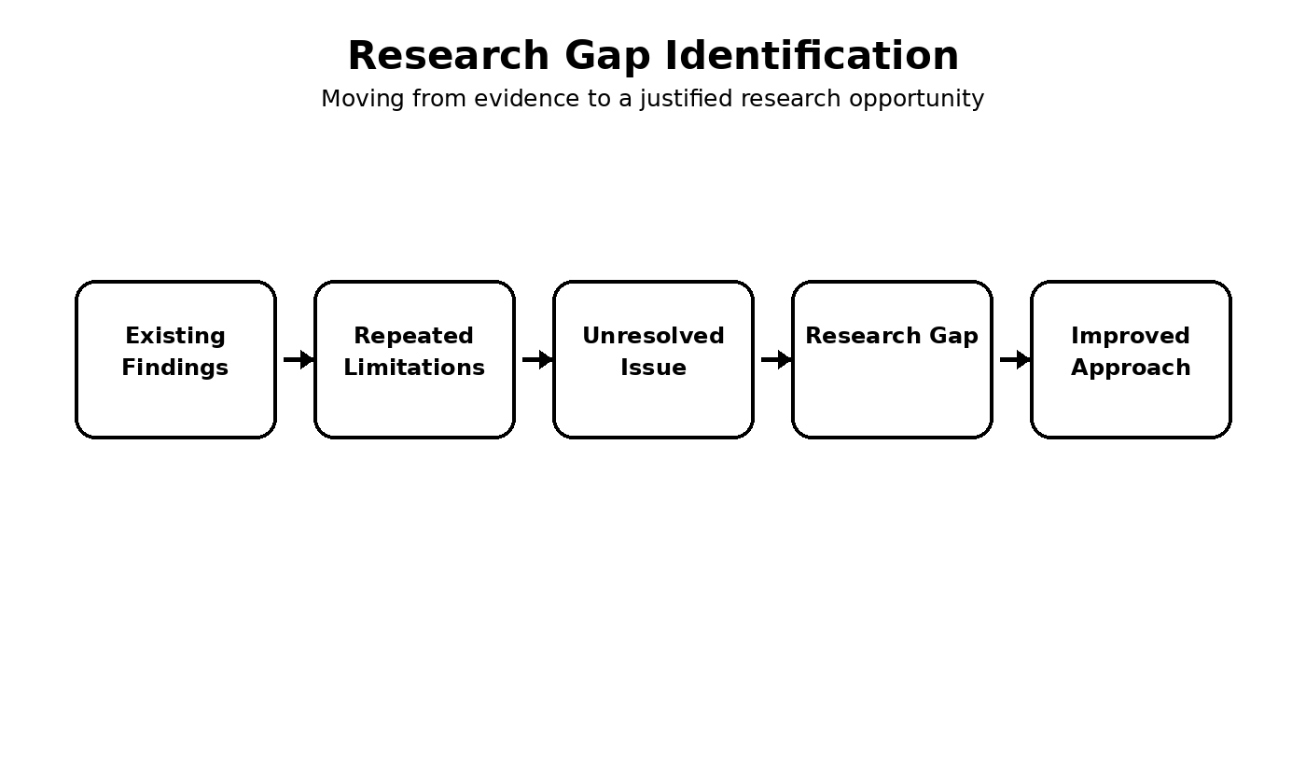
7. RESEARCH GAP IDENTIFICATION
A research gap is an unresolved issue that becomes visible after comparing existing studies. The gap should be derived from the literature rather than introduced without evidence. A strong gap connects the limitations of existing approaches with a clear opportunity for improvement.
Research Gap Identification Flowchart
Existing Research
↓
Multiple Approaches and Findings
↓
Compare Strengths and Limitations
↓
Identify Repeated or Significant Limitation
↓
Determine Unresolved Issue
↓
Formulate Research Gap
↓
Propose Improved Approach
Gap Analysis Matrix
Literature Observation | Limitation | Unresolved Issue | Potential Gap
Approach performs well in limited setting | Limited evaluation | Broader validation needed | Robust evaluation framework
System handles current workload | Scalability concern | Large-scale behavior uncertain | Scalable solution
Method uses substantial resources | Efficiency concern | Resource optimization needed | Efficient implementation
Study uses restricted data | Generalization concern | Diverse conditions not tested | Broader dataset and validation
Technology is promising | Deployment complexity | Practical adoption uncertain | Simplified deployable architecture
How to State the Gap
A clear research gap can be written in four parts: identify what existing studies have achieved, identify the limitation that remains, explain why the limitation matters, and state what kind of improvement is required. This makes the proposed future work logically connected to the reviewed literature.
Example Structure: “Existing studies provide effective solutions for the identified problem; however, limitations remain in scalability, evaluation, efficiency, or practical deployment. Therefore, further research is required to develop and evaluate an approach that addresses these limitations under broader and more realistic conditions.”
8. FUTURE RESEARCH DIRECTIONS AND RELEVANCE
The assessment requires future directions that are practical, innovative, and directly relevant to the identified problem. Future work should therefore be presented as specific improvements rather than broad statements.
Future Direction | Purpose | Expected Benefit
Improved scalability | Support increasing workload or users | Better large-scale operation
Efficient implementation | Reduce computational/resource requirements | Lower operational burden
Broader evaluation | Test across varied conditions | Improved reliability
Diverse datasets | Increase representation of real conditions | Better generalization
Hybrid approaches | Combine complementary techniques | Balanced performance and flexibility
Responsible design | Consider security, privacy, and maintainability | Safer long-term adoption
Continuous evaluation | Monitor system behavior over time | Better software evolution
Proposed Future-Work Flow
Research Gap
↓
Define Improvement Objective
↓
Select Suitable Technology / Method
↓
Develop Prototype or Model
↓
Evaluate Performance, Scalability and Efficiency
↓
Compare With Existing Approaches
↓
Validate Practical Relevance
↓
Refine and Evolve System
Relevance to Software Engineering
Future directions should contribute to software systems that are effective and maintainable. The CO5 statement emphasizes evaluating emerging technologies and societal impacts while maintaining and evolving systems responsibly. Therefore, future work should balance technical performance with operational feasibility, responsible use, maintainability, and long-term system requirements.
Expected Contribution
- A clearer understanding of current approaches.
- A structured comparison of research methods.
- Identification of major limitations and unresolved issues.
- A justified research gap.
- Practical directions for future system improvement.
- Better alignment between emerging technology and responsible software engineering.

9. CONCLUSION, REFERENCES AND ASSESSMENT ALIGNMENT
Conclusion
The literature survey framework presented in this report provides a systematic method for reviewing research papers related to an assigned Software Engineering problem statement. It begins with identification and selection of relevant research and continues through paper-level review, comparative analysis, critical evaluation, research-gap identification, and future directions.
The major value of a literature survey lies in connecting findings across studies. A structured comparison helps reveal differences in methodology, tools, datasets, performance, scalability, and efficiency. Critical analysis then converts these observations into a justified research gap. Finally, future directions translate the gap into practical opportunities for improvement.
The report structure is aligned with the supplied assessment requirements: relevant paper selection, detailed reviews, comparative analysis, critical research-gap analysis, future directions, and proper documentation. The assessment rubric also emphasizes clear presentation and consistent citations and references.
Assessment Alignment
Assessment Criterion | Weightage | How This Report Addresses It
Selection & Review of Research Papers | 25% | Structured paper-review format and review methodology
Comparative Analysis | 20% | Comparative tables and evaluation parameters
Critical Analysis & Research Gap | 25% | Limitations, challenge-impact analysis and gap matrix
Future Directions & Relevance | 15% | Future-work table and improvement flow
Documentation, Citations & References | 15% | Clean academic structure and reference section
References
The supplied source document provides the assessment instructions and rubric but does not contain the bibliographic details of individual research papers. Therefore, specific paper references should be inserted only after the selected papers are identified. This avoids inventing authors, years, titles, journals, datasets, or findings that are not supported by the source.
- Research Paper 1: Author(s), “Title,” Journal/Conference, Year, DOI/URL if applicable.
- Research Paper 2: Author(s), “Title,” Journal/Conference, Year, DOI/URL if applicable.
- Research Paper 3: Author(s), “Title,” Journal/Conference, Year, DOI/URL if applicable.
- Research Paper 4: Author(s), “Title,” Journal/Conference, Year, DOI/URL if applicable.
- Research Paper 5: Author(s), “Title,” Journal/Conference, Year, DOI/URL if applicable.

